Instructions for Test Console Setup

(Windows):

Pre-requisites:

- Jenkins
- Python
- PIP
- GIT
- Virtual Environment

Jenkins:

- Download the installer from link https://jenkins.io/content/thank-you-downloading-windows-installer/.
* Here we are downloading version 2.23
- Run the installer using admin access.

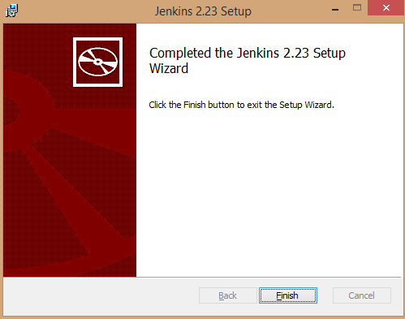

- Link on the finish button.
- User will be prompted for Admin password. Please note this is not the same password as computed password.
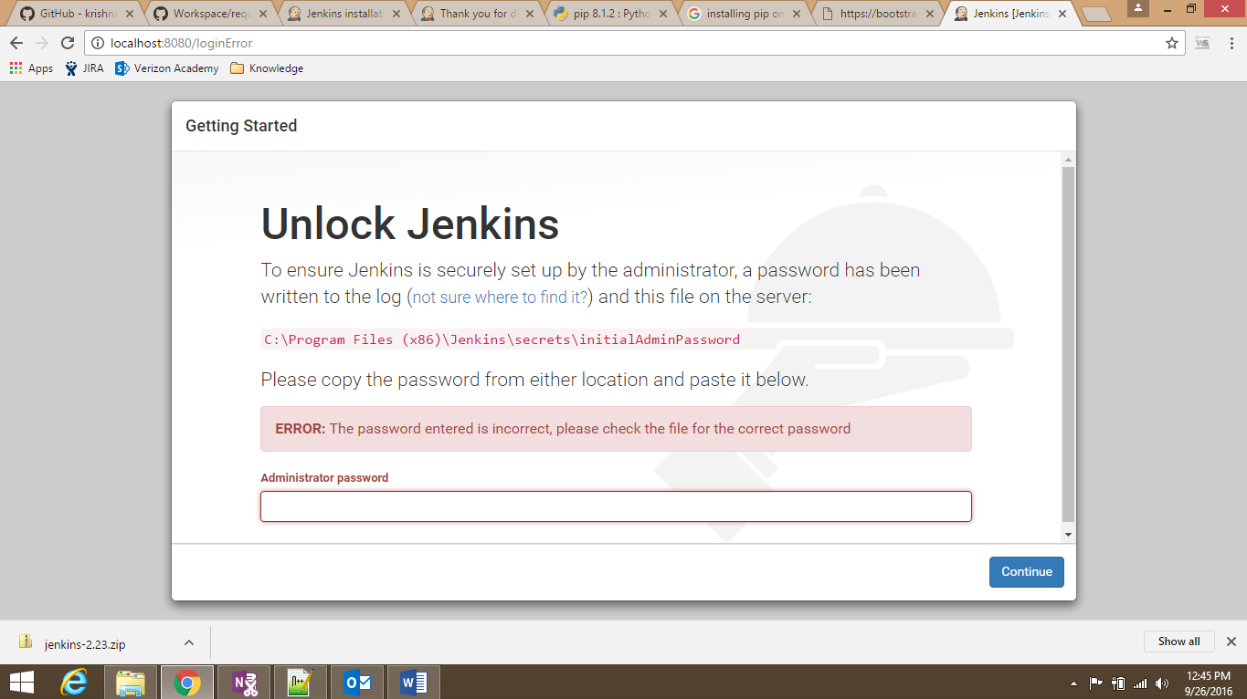

- Open with notepad below path-
C:\Program Files (x86)\Jenkins\secrets\initialAdminPassword
- Copy the text and enter in administrator password, then hit continue.
- Select the first option in the window “Install Plugins”. Then plugin will start downloading as below screen.
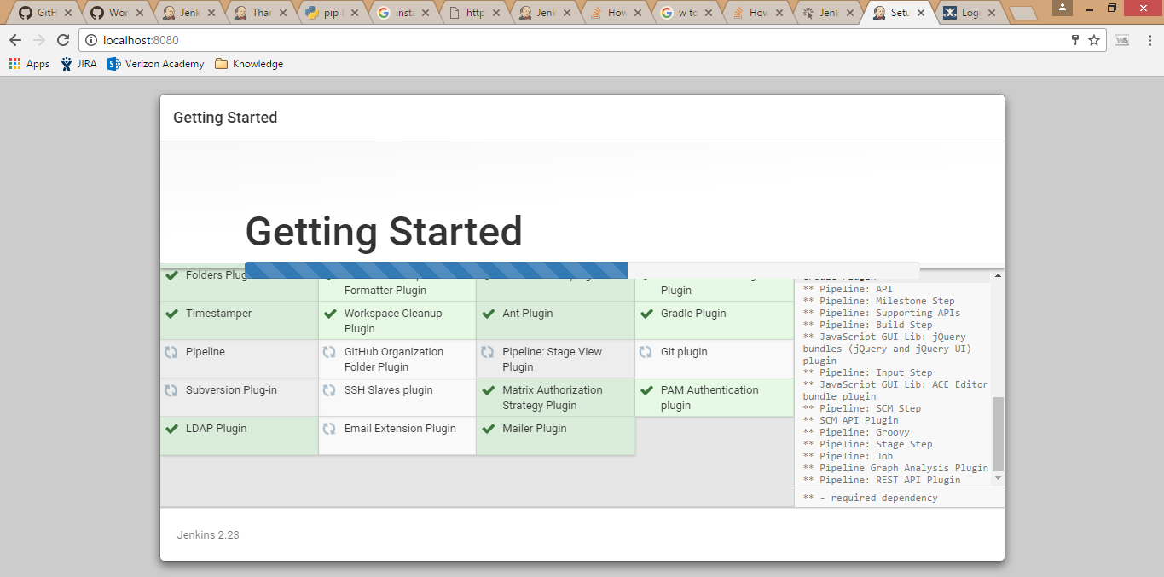
- Let the download finish.
- The next screen will prompt for Admin user creation.

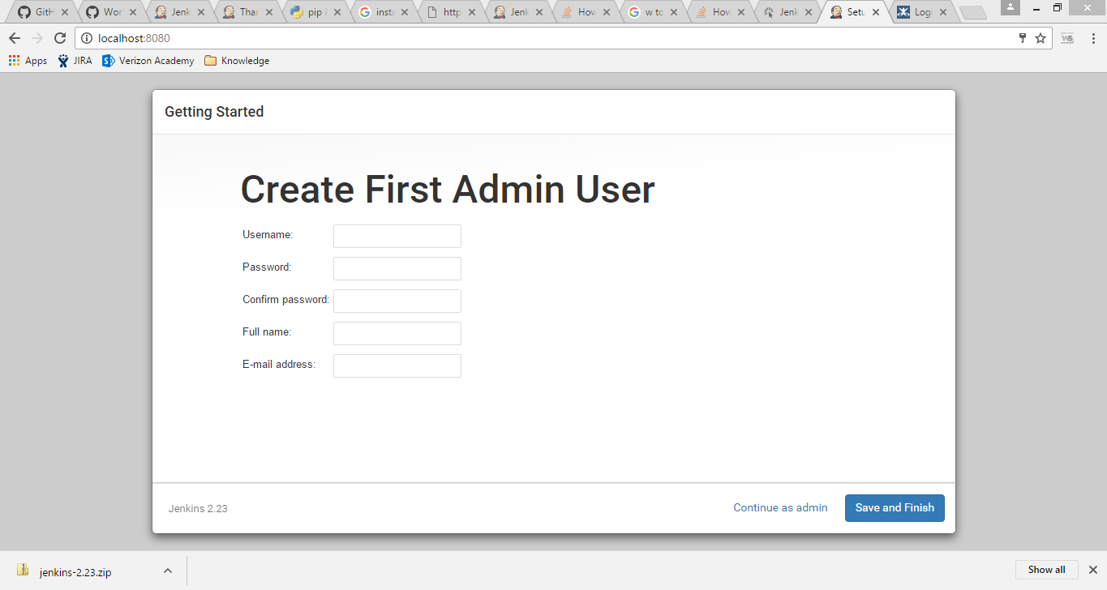
- Enter the details and “continue as admin”
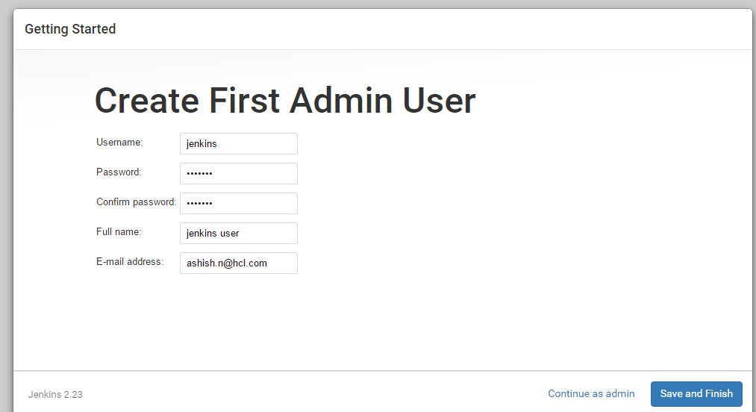
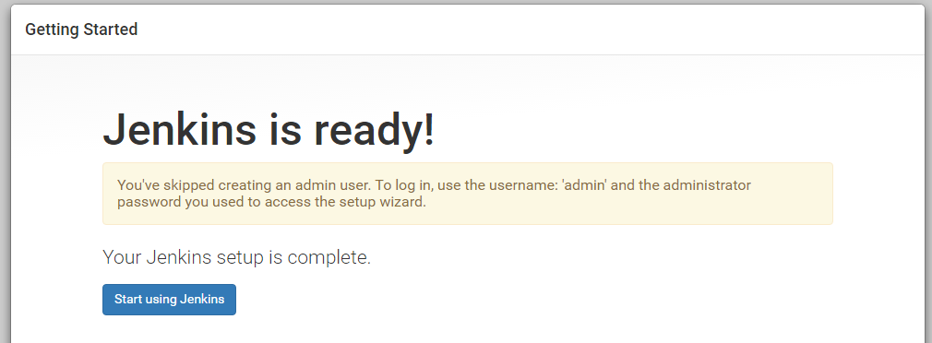
- The Jenkins is setup successfully. Click “Start using Jenkins” for confirmation. It will
redirect to Jenkins page.

Note: We have to create a job manually, If jenkins is already installed. Name the job as sample,
since it is the default job specified in our code. The following steps will help in creating a job.
- Create a new job by clicking on create new jobs

- Enter the item name as sample, and click on Freestyle project and then click ok.

- It will direct to this page. Under ‘Build’, click on ‘Add build step’ and then click on ‘Execute shell’ and then click on ‘Apply’ and ‘Save’.

- Now we can see the created job ‘sample’ on the Jenkins dashboard.

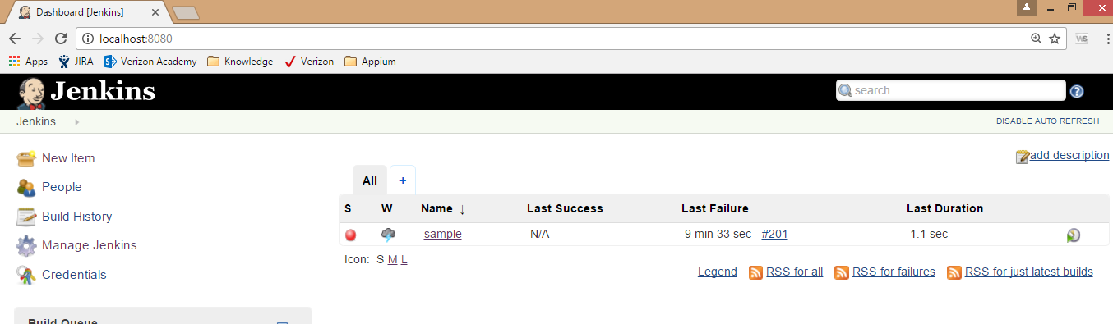

********Please note in case the User and Password is not working in Jenkins, please use below steps to bypass Username and Password. ********
- Go to C:\Program Files (x86)\Jenkins\config.xml‬‬
- Change the value
<useSecurity>true</useSecurity>
to <useSecurity>false</useSecurity>
and save.
- Go to services by entering “services.msc” in Run.
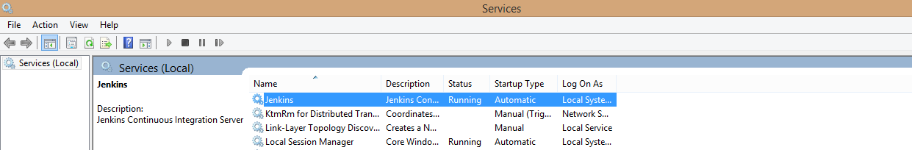
- Restart the Jenkin service.
- Open Jenkin in browser (http://localhost:8080/), and this time it should not ask for Username and Password anymore.
Please note in case the username and password are bypassed change the below line of code in view.py file (...\Workspace\app\view.py)
j = jenkins.Jenkins('http://localhost:8080', 'jenkins', 'jenkins123')
to j = jenkins.Jenkins('http://localhost:8080')

Install Python Plugin
- Go to Jenkin’s menu
- Select Manage Plugin
- Search for “Python Plugin”
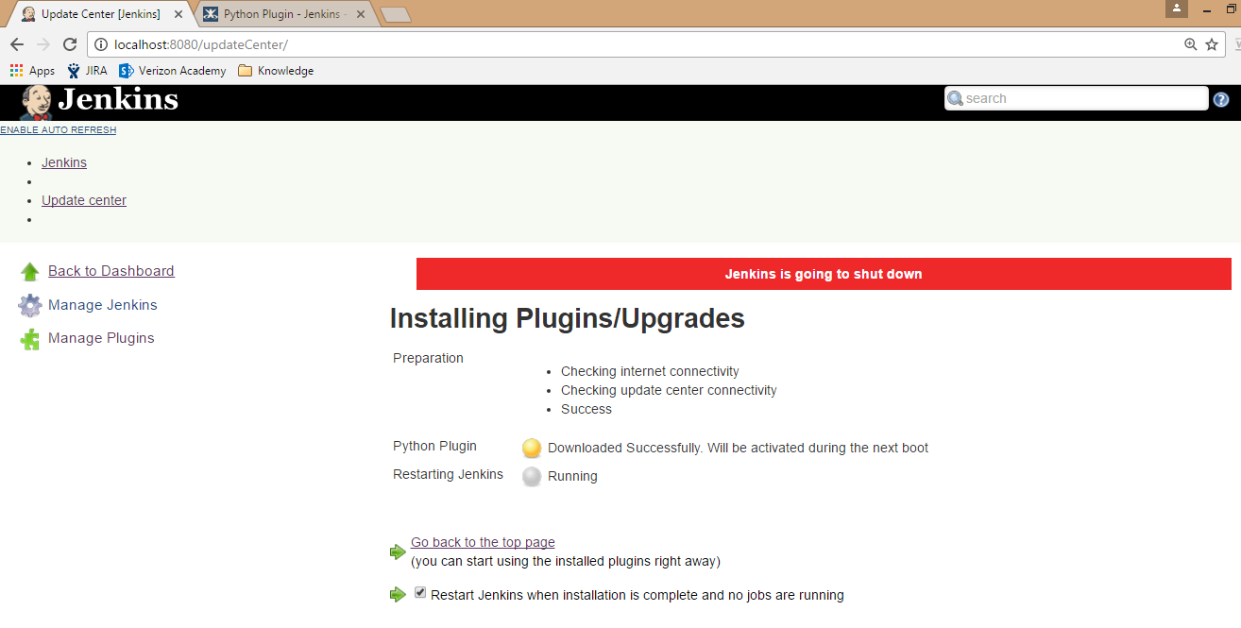

Python (2.7.12):

- Click on the below link for Python installation -
Windows x86-64 MSI installer
- Run the downloaded python-2.7.12.amd64.exe

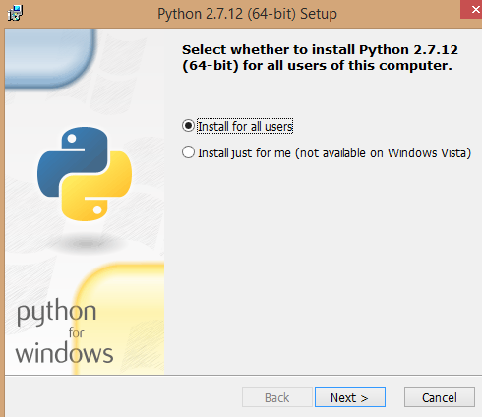
- Once the installation is ciompleted successfully update the environment variable as below.

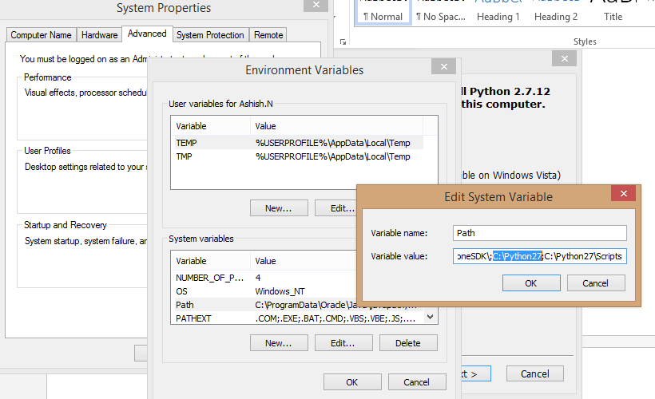
--------------------------------------------------------------------------------------------------------------------------------------

PIP: (The recommended tool for installing Python packages)
* The system should have Python already installed
- Go to link https://pip.pypa.io/en/stable/installing/ and download get-pip.py by right clicking and save link as.
* Please ensure it has to be a python file (*.py)
- Go to command prompt and run the python file.
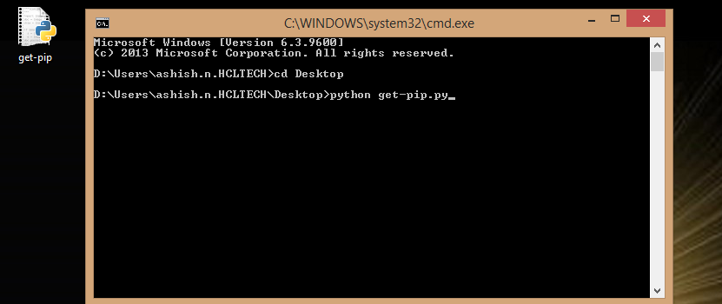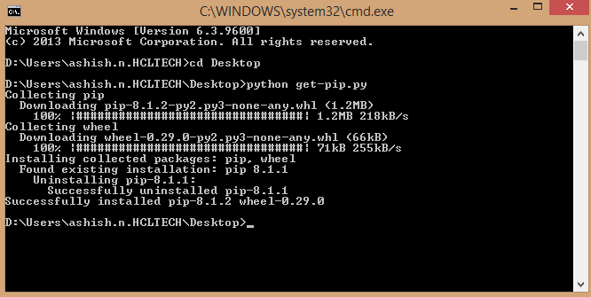
- The PIP will be installed in the system.
- Update the system variable My Computer | <Right Click> Properties| Advanced System Settings.

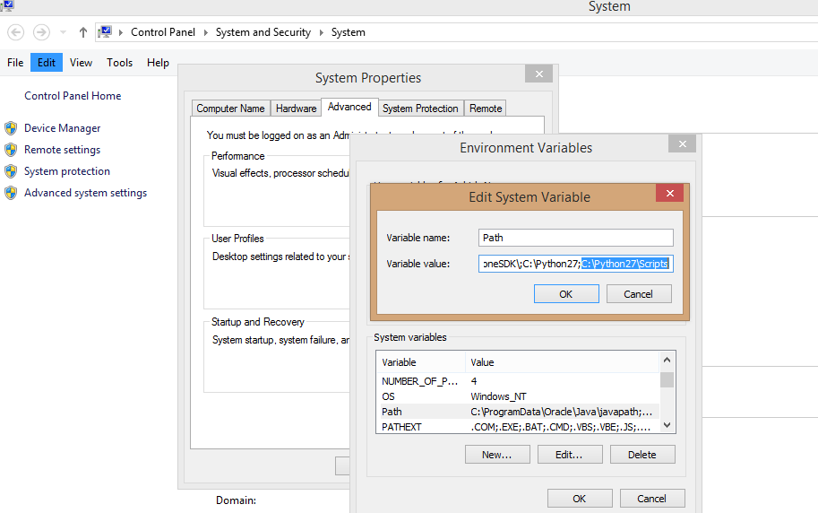

- PIP installed successfully.

GIT
- Open https://git-scm.com/download/win
- GIT will start download
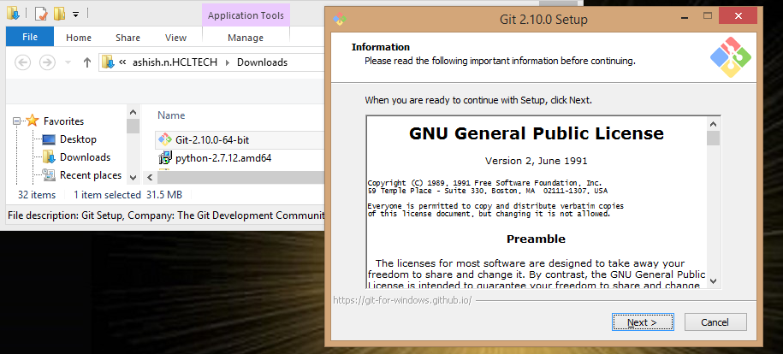
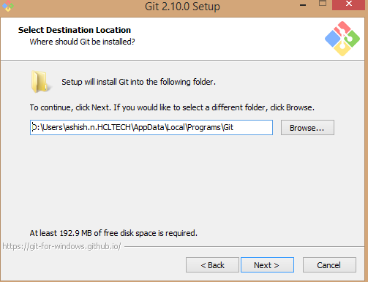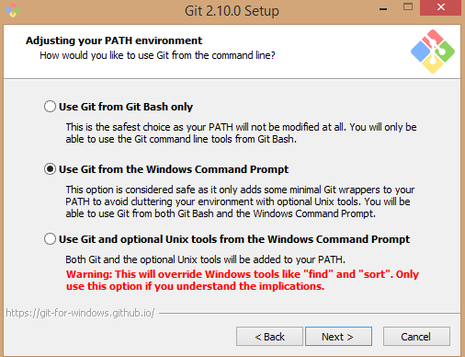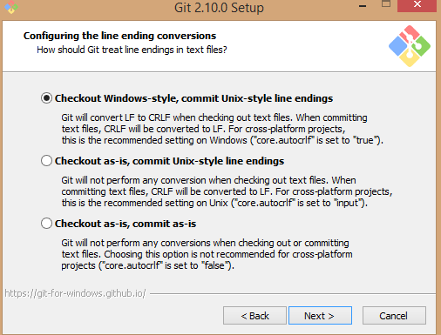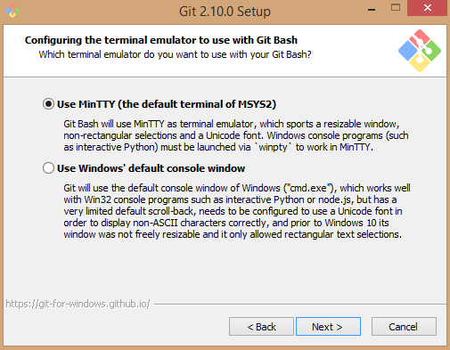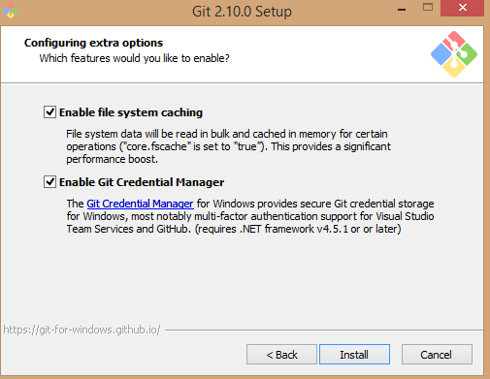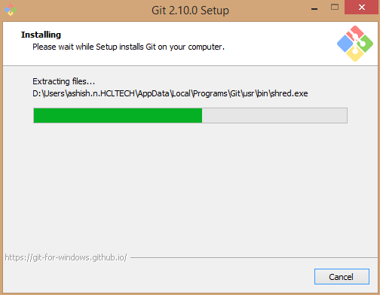
- Git created scuccessfully in Local Programs “D:\Users\ashish.n.HCLTECH\AppData\Local\Programs\Git”.

Virtual Environment
- Go to cmd and enter “pip install virtualenv”
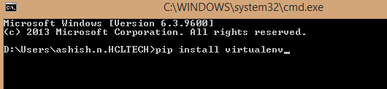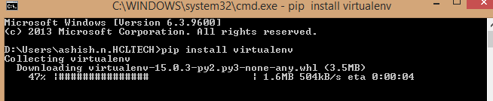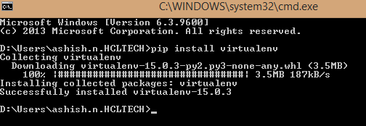

- Create project folders
Commands to follow to create the project
- D:\Users\ashish.n.HCLTECH>mkdir Project
- D:\Users\ashish.n.HCLTECH>cd Project

- Download Git Hub Project. (https://github.com/krishnaprasad536/Workspace )
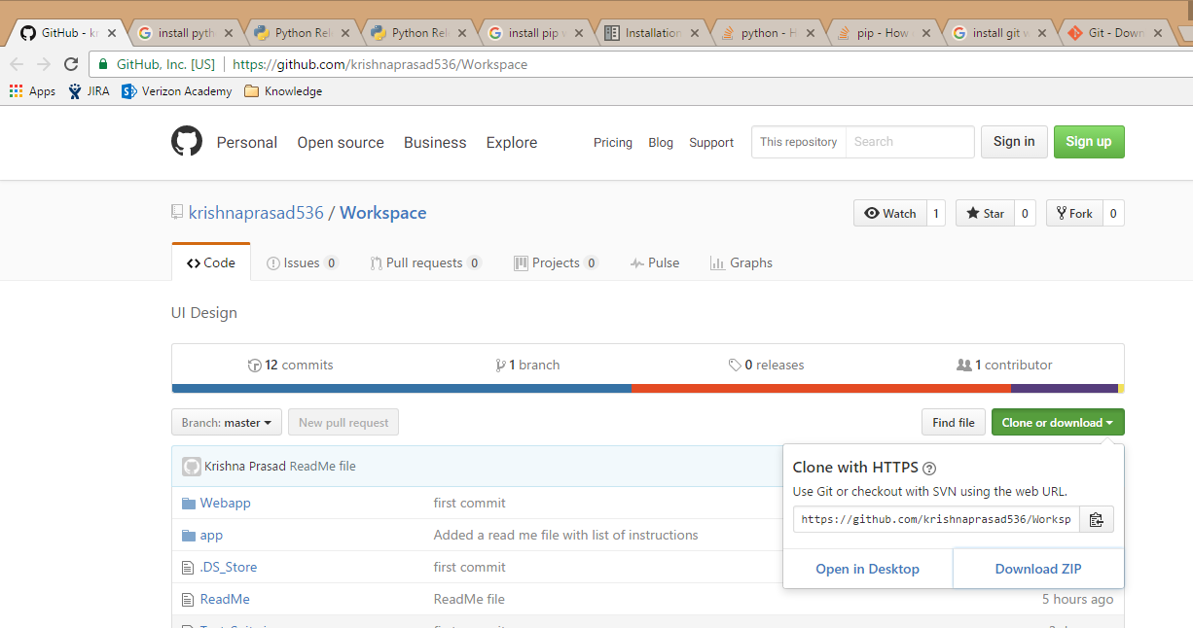

- Move the downloaded project into “Project” folder.

- Create virtual environment by running command on cmd
- Navigate to project folder and enter below commands
(VE1) D:\Users\ashish.n.HCLTECH\Project>cd Workspace-master

- D:\Users\ashish.n.HCLTECH\Project\Workspace-master>virtualenv VE1
- (Create virtual environment in home directory)
- D:\Users\ashish.n.HCLTECH\Project\Workspace-master >VE1\Scripts\activate
* <VE1> name of virtual environment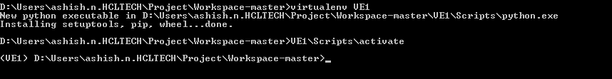

Run below listed commands -

- (VE1) D:\Users\ashish.n.HCLTECH\Project\Workspace-master>pip install -r requirements.txt
- (VE1) D:\Users\ashish.n.HCLTECH\Project\Workspace-master>pip freeze
- (VE1) D:\Users\ashish.n.HCLTECH\Project\Workspace-master>python manage.py syncdb
- (VE1) D:\Users\ashish.n.HCLTECH\Project\Workspace-master>python manage.py migrate
- (VE1) D:\Users\ashish.n.HCLTECH\Project\Workspace-master>python manage.py runserver

